Experiment 2

Student Name: Aditi R Sinha UID: 22BCS15130

Branch: BE-CSE Section/Group: 22BCS_KRG_IOT-2-B

Semester:6th Date of Performance: 13/01/2025

Subject Name: Project Based Learning Subject Code: 22CSH-359 in Java with Lab

1. Aim: Design and implement a simple inventory control system for a small video rental store.

1. Objective:

The goal of this project is to design and implement a simple inventory control system for a small video rental store. Define least two classes: a class Video to model a video and a class VideoStore to model the actual store.

Assume that an object of class Video has the following attributes: a title, a flag to say whether it is checked out or not and an average user rating. Add instance variables for each of these attributes to the Video class.

In addition, you will need to add methods corresponding to the following: being checked out, being returned and receiving a rating.

The VideoStore class will contain at least an instance variable that references an array of videos (say of length 10). The VideoStore will contain the following methods:

* + addVideo(String): add a new video (by title) to the inventory
  + checkOut(String): check out a video (by title)
  + returnVideo(String): return a video to the store
  + receiveRating(String, int) : take a user's rating for a video • listInventory(): list the whole inventory of videos in the store.

Finally, create a VideoStoreLauncher class with a main() method which will test the functionality of your other two classes. It should allow the following.

* + Add 3 videos: "The Matrix", "Godfather II", "Star Wars Episode IV: A New Hope".
  + Give several ratings to each video.
  + Rent each video out once and return it. List the inventory after "Godfather II" has been rented out.

1. Implementation/Code:

import java.util.*; class video{ public String title; public boolean checkedOut; public double userRating; public int rateCount; public video(String title){ this.title = title; this.checkedOut = false; this.userRating = 0;

this.rateCount = 0;

}

public String getTitle(){

return title;

}

public double getUserRating(){

if(rateCount == 0){

return 0;

}else{

return userRating/rateCount;

}

}

public void checkOut(){ if(!checkedOut){ checkedOut = true;

}else{

System.out.println(title + " is already checked out");

}

}

public void returnVideo(){ if(checkedOut){ checkedOut = false;

}else{

System.out.println(title + " is not checked out");

}

}

public void receiveRating(double rating)

{

if(rating >= 1 && rating<=5){ userRating += rating; rateCount++; }else{

System.out.println("Invalid rating! Please enter rating between 1 and 5");

}

}

public String toString(){ return "\nTitle: "+ title+"\nCheckedOut: "+ checkedOut+"\nAverage user rating: "+getUserRating();

}

}

class videoStore{

private ArrayList<video>Videos; public videoStore(){

this.Videos = new ArrayList<>();

}

public void addVideo(String title){

Videos.add(new video (title));

System.out.println(title + " added to the list");

}

public void checkOut(String title){ video video = findVideo(title);

if(video != null){ video.checkOut();

System.out.println("Checked Out: " + title);

}else

{

System.out.println(title + " Video not found.");

}

}

public void returnVideo(String title){ video video = findVideo(title);

if(video != null){ video.returnVideo();

System.out.println(title + " is returned");

}else{

System.out.println(title + " Video not found.");

}

}

public void receiveRating(String title, int rating){ video video = findVideo(title); if(video != null){

video.receiveRating(rating);

System.out.println(title + " recieved rating of "+rating);

}else{

System.out.println(title + " Video not found.");

}

}

public void VideoList(){

System.out.println("\nVideo Inventory: ");

for(video video : Videos){ System.out.println(video);

}

}

private video findVideo(String title){ for(video video : Videos){

if(video.getTitle().equalsIgnoreCase(title)){

return video;

}

}

return null;

}

}

public class exp2 { public static void main(String[] args) { videoStore store = new videoStore(); store.addVideo("The Matrix"); store.addVideo("Godfather II");

store.addVideo("Star Wars Episode IV : A New Hope");

store.receiveRating("The Matrix", 3); store.receiveRating("The Matrix", 2); store.receiveRating("Godfather II", 5); store.receiveRating("Godfather II", 4); store.receiveRating("Star Wars Episode IV : A New Hope", 4); store.receiveRating("Star Wars Episode IV : A New Hope", 3); store.checkOut("The Matrix"); store.checkOut("Godfather II"); store.returnVideo("The Matrix");

store.VideoList();

}

}

1. Output:

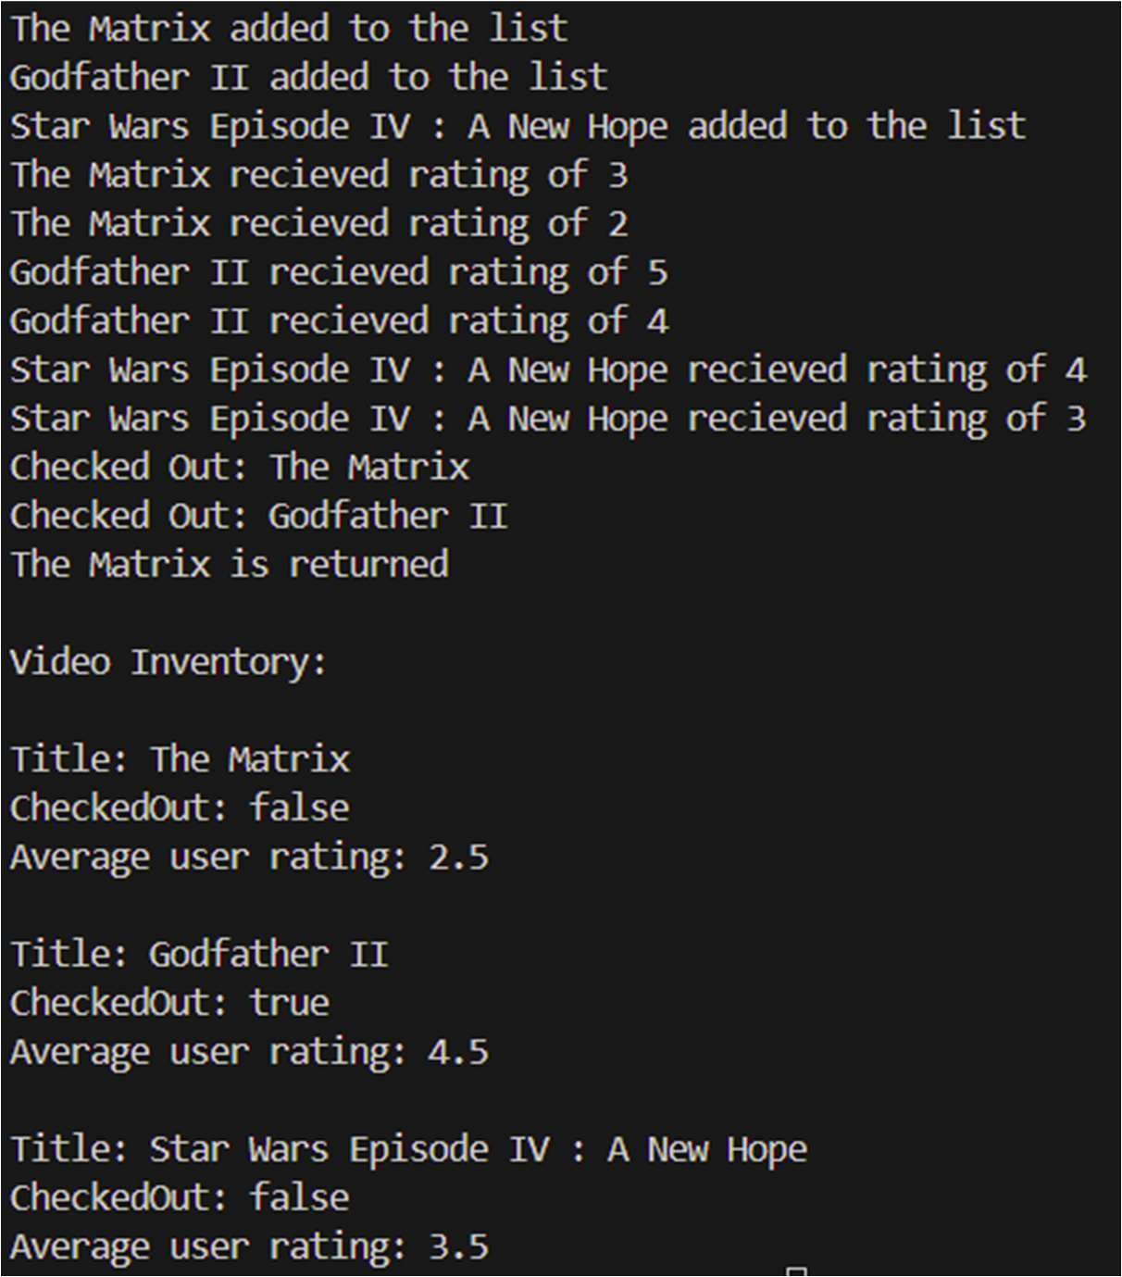

DEPARTMENT OF

COMPUTER SCIENCE & ENGINEERING

1. Learning Outcomes:

i. Understanding of Class and Object Concepts in Java ii. Implementation of Arrays and Iteration iii. Implementation of Scanner Class in Java